WINDOWS FUNDAMENTALS 1
Expt:1
Aim:
To gain a comprehensive understanding of the Windows operating system by exploring its graphical user interface, file system architecture, built-in security features, system management tools, networking capabilities, user account management, and advanced administrative utilities. This experiment uses the TryHackMe Windows Fundamentals 1 room to provide a structured, hands-on learning experience for beginners approaching Windows security and administration.

Procedure:
Windows Fundamentals 1:
- Logged in to the TryHackMe platform using registered credentials and navigated to the Windows Fundamentals 1 room to begin the structured learning exercise.
- Explored the Windows desktop environment in detail, including the layout and functionality of the Start Menu, Taskbar, notification area (system tray), and the Settings application, understanding how these components form the primary interface for user interaction with the Windows OS.
- Opened and explored File Explorer, examining the navigation pane, address bar, ribbon menu, and quick access shortcuts. Practiced creating, renaming, moving, and deleting files and folders while understanding the hierarchical structure of the Windows file system.
- Studied the purpose and location of essential Windows user profile folders including Desktop, Documents, Downloads, Pictures, and AppData. Understood how these directories are organized under the user profile path (C:\Users\[username]) and their significance in user data management.
- Explored the Control Panel and the modern Windows Settings application, examining configuration options for system preferences, display settings, user accounts, network connections, privacy controls, and update management. Compared the legacy Control Panel interface with the newer Settings UI introduced in Windows 10/11.
- Completed all interactive tasks provided in the room, including answering comprehension questions, navigating simulated Windows environments, and demonstrating understanding of core Windows concepts. Successfully submitted all answers to advance through the room.

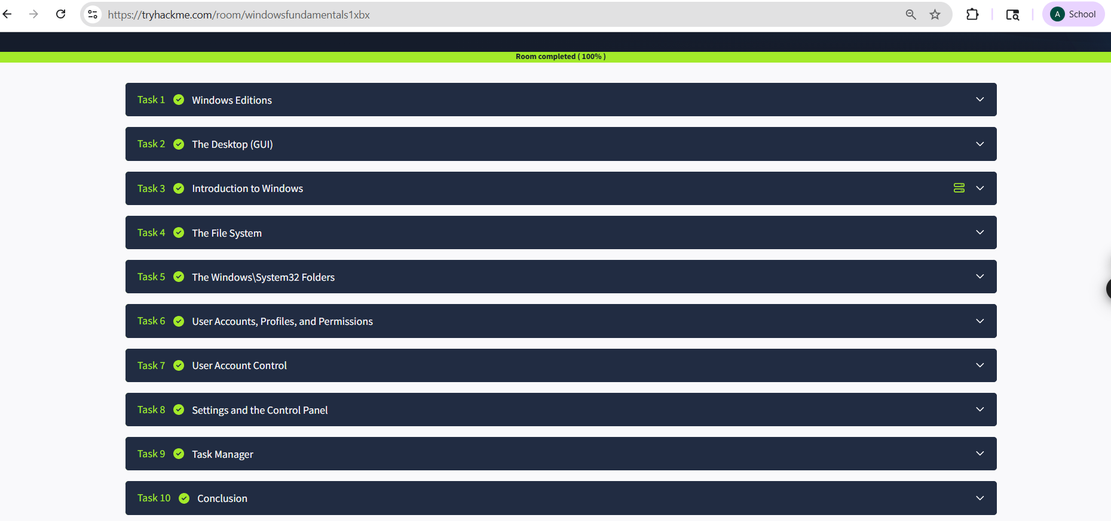

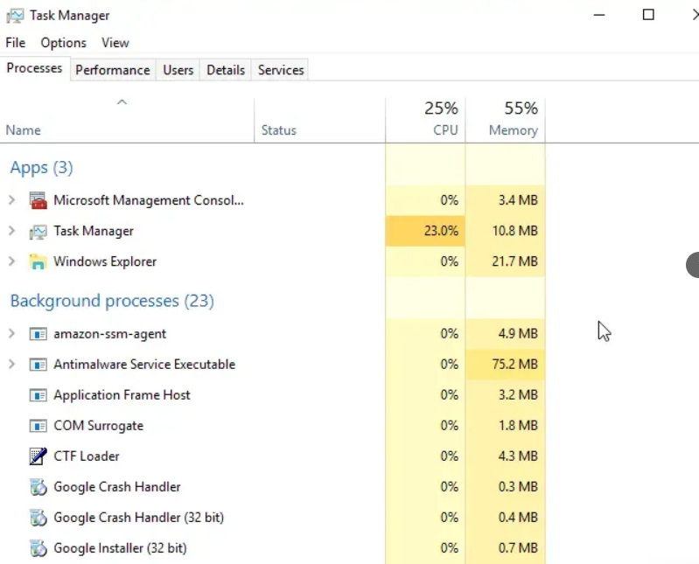

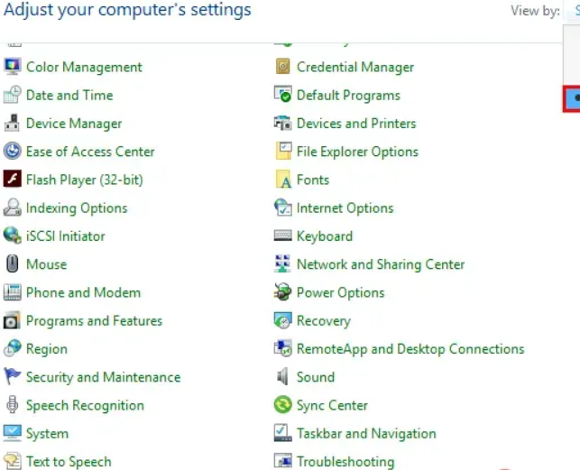

Result:
Thus, the Windows Fundamentals 1 room was completed successfully in TryHackMe. Comprehensive knowledge of the Windows operating system was gained, spanning basic navigation of the desktop environment and file system to an understanding of system tools, control panel utilities, and built-in security features. This foundational knowledge provides essential groundwork for further exploration of Windows security and administration.

WINDOWS FUNDAMENTALS 2

Aim:
To develop an in-depth understanding of advanced Windows operating system features by exploring the NTFS file system, User Account Control (UAC), Task Manager, Event Viewer, and service management. This experiment utilizes the TryHackMe Windows Fundamentals 2 room to build practical knowledge of Windows security mechanisms, process management, and administrative tools essential for cybersecurity professionals.

Procedure:
Windows Fundamentals 2:
- Opened the Windows Fundamentals 2 room in TryHackMe.
- Studied the NTFS (New Technology File System) used by Windows, including its features such as file-level security, compression, encryption (EFS), disk quotas, and journaling. Examined how NTFS permissions (Read, Write, Execute, Full Control) are applied to files and folders and how inherited vs. explicit permissions interact.
- Analyzed the User Account Control (UAC) mechanism in Windows, understanding how it restricts application execution to standard user privileges unless elevated. Examined UAC prompt behavior, the distinction between standard users and administrators, and how UAC prevents unauthorized system changes and privilege abuse.
- Used the Task Manager (taskmgr.exe) to monitor running processes, CPU/memory usage, startup programs, and services. Explored System Configuration (msconfig.exe) for managing boot options and startup items. Analyzed Event Viewer to interpret Windows log entries across System, Application, and Security log categories.
- Studied the Windows process model including how the operating system creates, schedules, and terminates processes. Examined Windows services as background processes managed by the Service Control Manager (SCM), and practiced starting, stopping, and modifying service configurations using the Services management console.
- Completed all room tasks including hands-on exercises within the lab environment, reviewed key concepts, and submitted accurate answers to all comprehension questions, confirming a solid understanding of Windows administrative tools and security mechanisms.

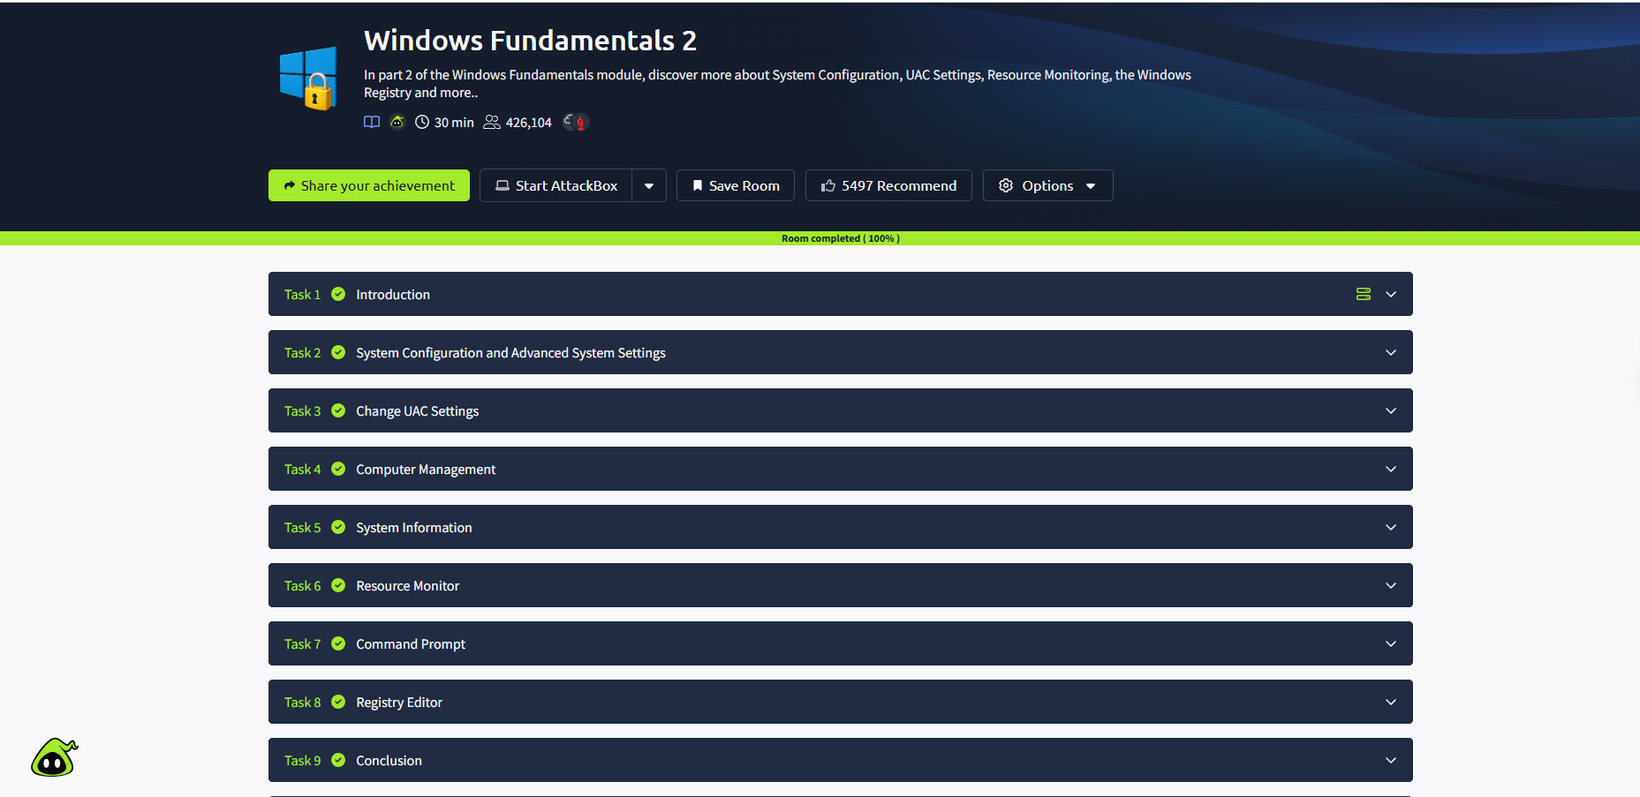

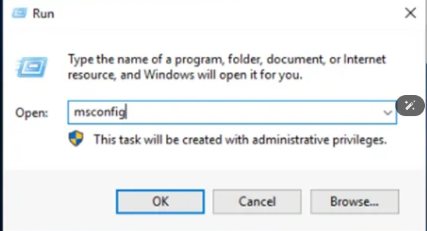

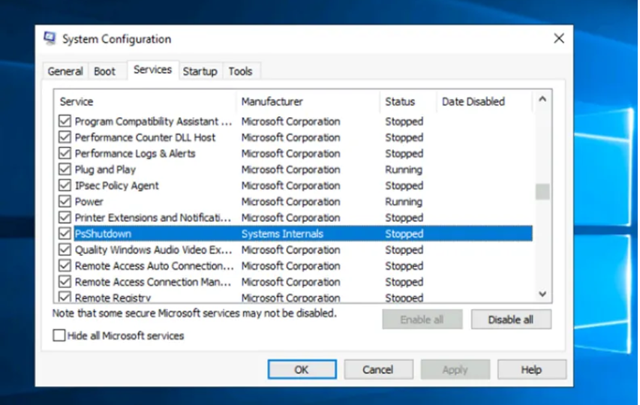
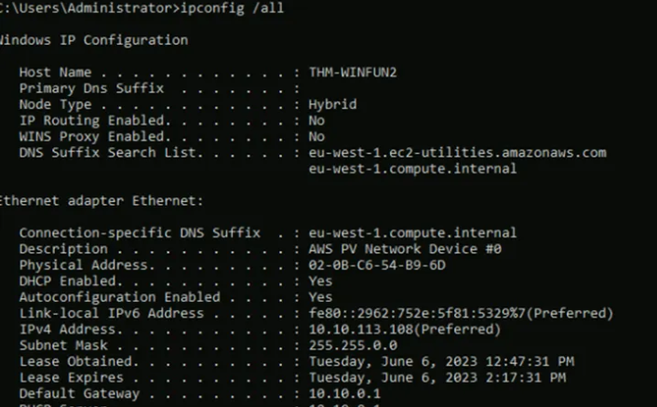

Result:
Thus, the Windows Fundamentals 2 room was completed successfully in TryHackMe. Detailed knowledge of the NTFS file system, User Account Control (UAC), Task Manager, System Configuration, Event Viewer, and Windows process and service management was acquired. These skills are critical for understanding how Windows manages security and system resources at an advanced administrative level.

WINDOWS FUNDAMENTALS 3

Aim:
To acquire advanced knowledge of Windows operating system security and management by studying Windows Update mechanisms, Windows Defender antivirus, firewall configurations, network administration tools, and PowerShell scripting fundamentals. This experiment employs the TryHackMe Windows Fundamentals 3 room to prepare students for real-world Windows system administration and cybersecurity tasks.

Procedure:
Windows Fundamentals 3:
- Opened the Windows Fundamentals 3 room.
- Studied the Windows Update service and its role in maintaining operating system security and stability by delivering security patches, feature updates, and driver updates. Examined update settings including automatic update configuration, Windows Update history, and the Windows Update for Business policy framework used in enterprise environments.
- Explored Windows Defender Antivirus including real-time protection, cloud-delivered protection, controlled folder access, and ransomware protection features. Examined the Windows Defender Firewall configuration for inbound and outbound rules, connection security rules, and network profile management (Domain, Private, Public).
- Practiced using command-line networking tools including ipconfig for IP address and DNS configuration, ping for connectivity testing, tracert for route tracing, netstat for active connection monitoring, and nslookup for DNS resolution. Understood how these tools are used for network diagnostics and troubleshooting in Windows environments.
- Introduction to Windows PowerShell as a powerful command-line shell and scripting language. Executed basic cmdlets such as Get-Process, Get-Service, Get-EventLog, and Set-ExecutionPolicy. Understood the pipeline concept, cmdlet syntax, and how PowerShell can be used for system administration, automation, and security operations.
- Successfully completed all interactive tasks, practical exercises, and comprehension questions within the room. Demonstrated a consolidated understanding of Windows security tools, update mechanisms, networking utilities, and PowerShell fundamentals required for real-world Windows administration.

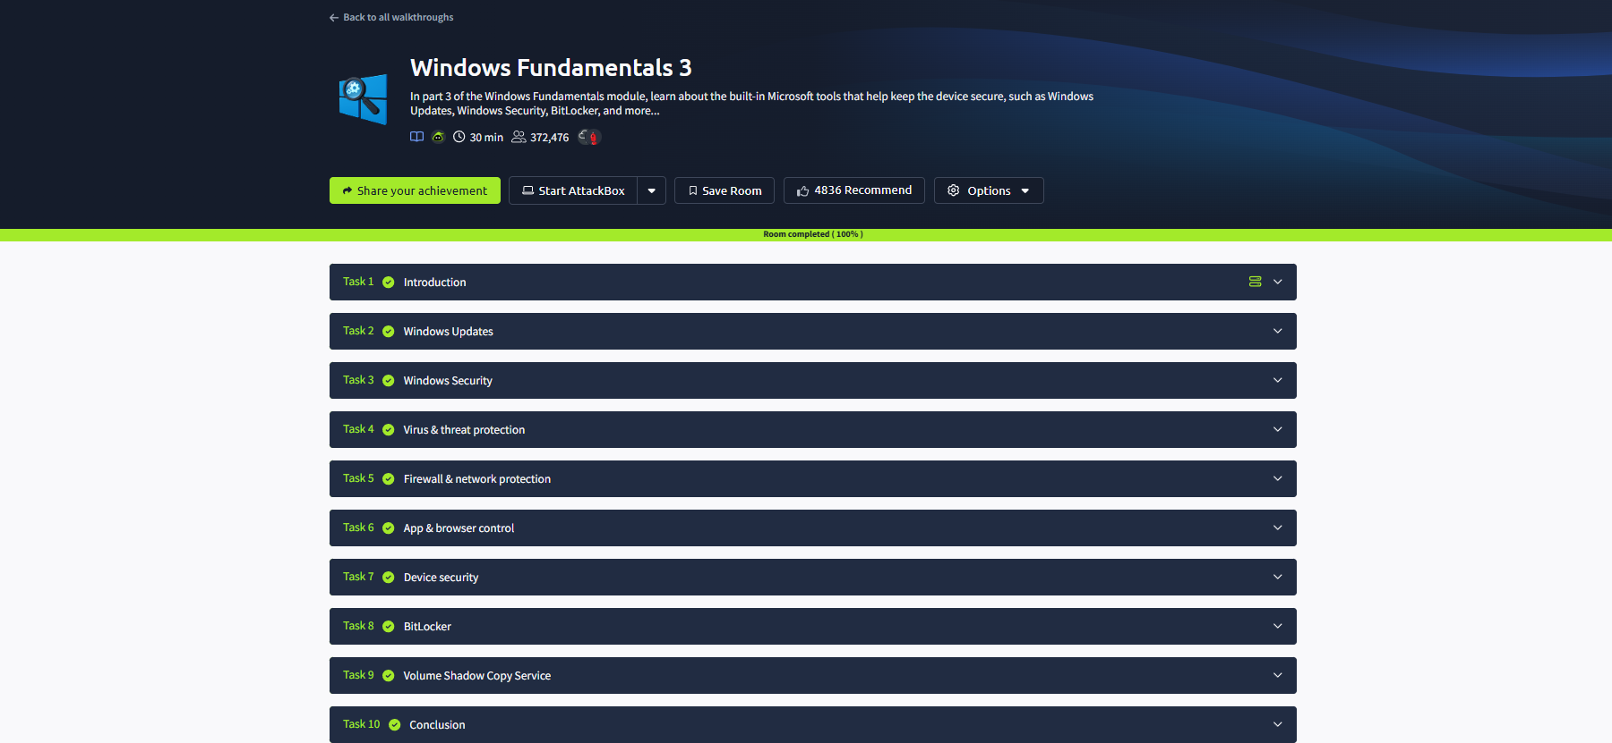

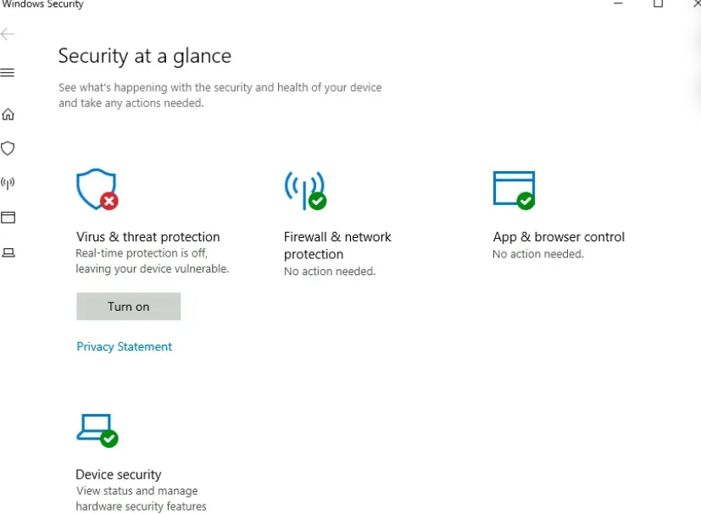
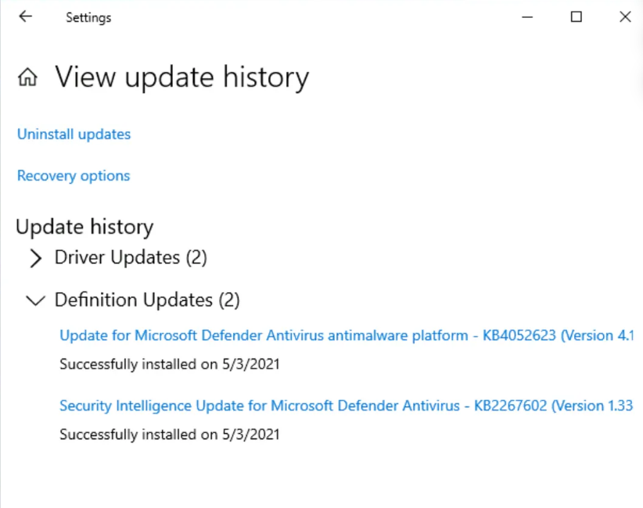
Result:
Thus, the Windows Fundamentals 3 room was completed successfully in TryHackMe. Advanced knowledge of Windows security features including Windows Update, Windows Defender, and the built-in firewall was gained. Additionally, practical exposure to networking tools, IP configuration utilities, and PowerShell scripting fundamentals equips students with the skills needed for real-world Windows system administration and cybersecurity roles.

SECURITY MODELS AND PRINCIPLES
Expt:2
Aim:
To develop a thorough understanding of the foundational security models and guiding principles that underpin modern information security practices. This experiment covers the CIA Triad, the principle of Least Privilege, access control models including DAC, MAC, and RBAC, as well as formal security models such as Bell-LaPadula, Biba, and Clark-Wilson. The goal is to equip students with the conceptual framework required to design and evaluate secure systems.

Procedure:
- Logged in to the TryHackMe platform using registered credentials and navigated to the Security Models and Principles room to begin the structured learning exercise.
- Learned the basic concepts of Confidentiality, Integrity, and Availability (CIA Triad).
- Studied the principle of Least Privilege, where users are given only the access required.
- Learned about Access Control Models such as:
  - Discretionary Access Control (DAC)
  - Mandatory Access Control (MAC)
  - Role-Based Access Control (RBAC)
- Examined formal mathematical security models designed to enforce specific security properties within computer systems:
  - Bell-LaPadula Model: A state-machine model focused on data confidentiality in multilevel security environments, enforcing the No Read Up (Simple Security Property) and No Write Down (*-Property) rules to prevent unauthorized information disclosure.
  - Biba Model: An integrity-focused formal model that enforces No Read Down and No Write Up rules, ensuring that higher-integrity subjects are not contaminated by lower-integrity data, commonly applied in environments requiring strict data accuracy.
  - Clark-Wilson Model: A real-world integrity model that uses well-formed transactions and separation of duties to ensure that data remains consistent and can only be modified through controlled, auditable procedures.
- Studied authentication methodologies including knowledge-based factors (passwords, PINs), possession-based factors (smart cards, security tokens), and inherence-based factors (fingerprints, facial recognition). Examined the security advantages of Multi-Factor Authentication (MFA) and how combining multiple authentication factors significantly reduces the risk of unauthorized access.
- Explored the risk management lifecycle including the identification of threats (potential attack vectors), vulnerabilities (system weaknesses that could be exploited), and the implementation of security controls (technical, administrative, and physical countermeasures) to reduce risk to an acceptable level.
- Completed all tasks and answered the room questions successfully.

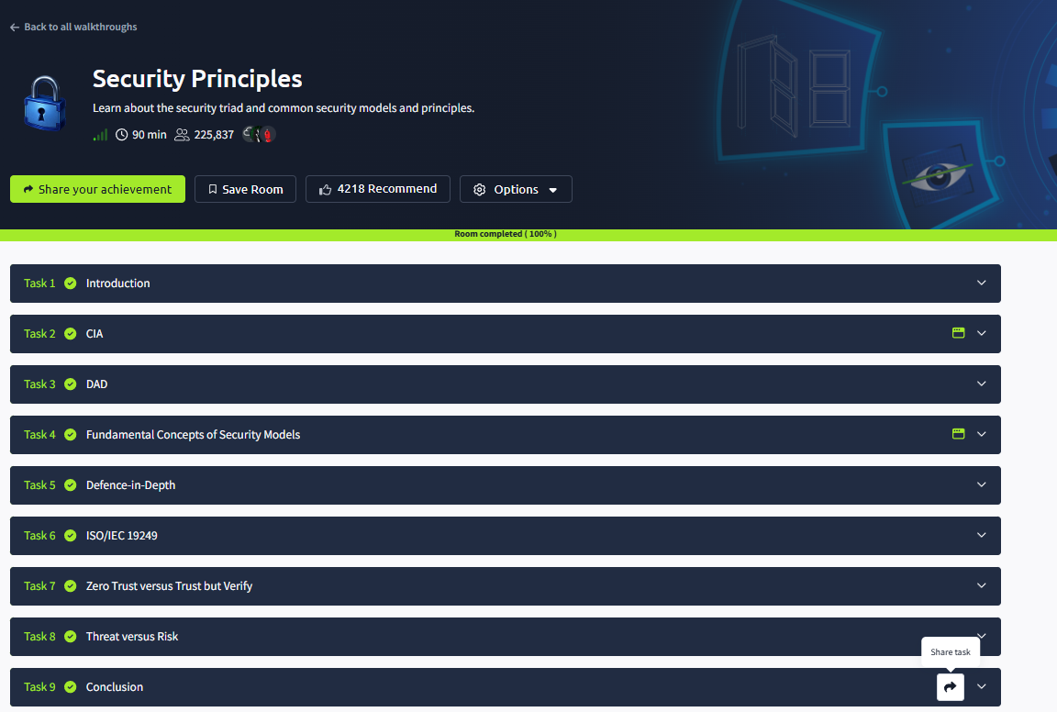

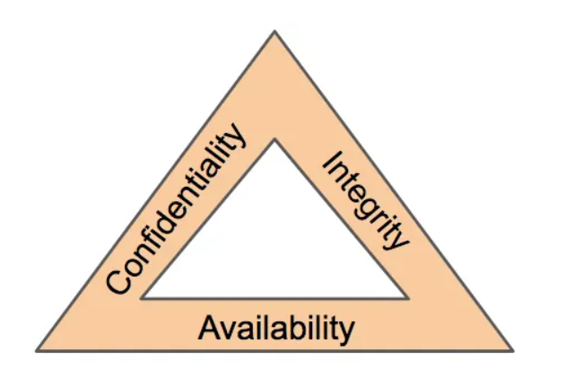

Result:
Thus, the Security Models and Principles room was completed successfully in TryHackMe. Knowledge about security principles, access control methods, and important security models used to secure systems and data was gained successfully.
NETWORK SECURITY ESSENTIALS
Expt:3
Aim:
To build a solid foundation in network security by examining common cyber threats, network vulnerabilities, and the defense mechanisms used to counter them. This experiment provides hands-on exposure to firewalls, intrusion detection and prevention systems, VPNs, secure protocols, and authentication methods through the TryHackMe Network Security Essentials room, enabling students to understand how organizations protect their network infrastructure.

Procedure:
- Logged in to the TryHackMe platform using registered credentials and navigated to the Network Security Essentials room to begin the structured learning exercise.
- Studied the foundational concepts of computer networking including the OSI and TCP/IP reference models, packet-switching principles, and the roles of key communication protocols such as TCP, UDP, IP, DNS, HTTP/HTTPS, and SMTP. Understood how data traverses network layers and the importance of protocol security in protecting communications.
- Analyzed a wide range of network-based cyber threats: malware propagation over networks, phishing and spear-phishing email attacks, ARP and IP spoofing techniques, packet sniffing using tools like Wireshark, and volumetric and protocol-based Denial-of-Service (DoS) and Distributed Denial-of-Service (DDoS) attacks. Examined real-world examples and their potential impact on network availability and data confidentiality.
- Examined the role and configuration of key network security hardware and software components: stateful and application-layer firewalls for traffic filtering, routers for inter-network traffic management, managed switches for VLAN-based network segmentation, and Intrusion Detection/Prevention Systems (IDS/IPS) for real-time threat detection and automated response.
- Studied encryption principles including symmetric and asymmetric cryptography, TLS/SSL certificate-based authentication, and how secure tunneling protocols such as VPNs (IPSec, OpenVPN) protect data in transit. Examined HTTPS as the secure extension of HTTP and SSH as a secure alternative to Telnet for remote system administration.
- Explored network authentication mechanisms including RADIUS, TACACS+, and 802.1X port-based access control. Studied how network access control (NAC) systems enforce security policies on devices attempting to connect to the network, ensuring only authenticated and compliant endpoints gain access.
- Reviewed IPv4 and IPv6 addressing schemes, subnetting, CIDR notation, and the role of TCP/UDP port numbers in service identification. Practiced basic network monitoring using tools to observe traffic, identify open ports, and detect anomalous communication patterns indicative of security incidents.
- Completed the practical tasks and answered all questions successfully.

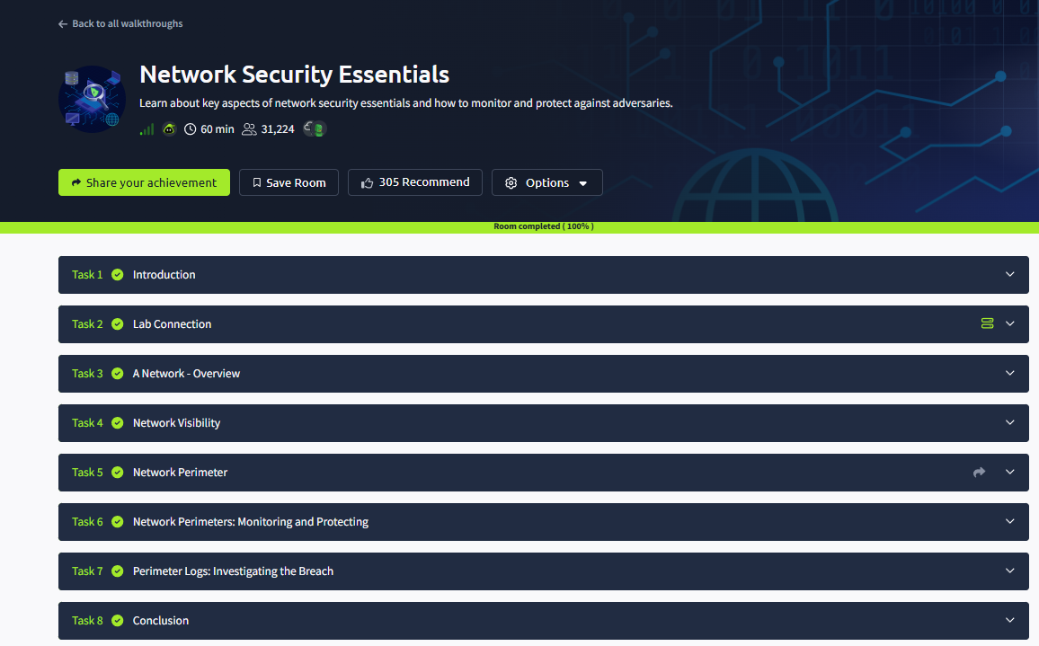
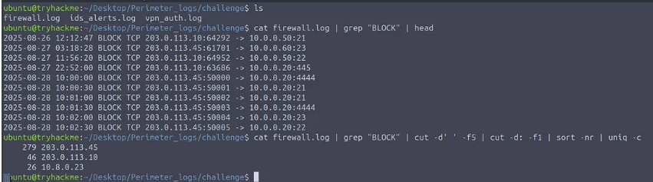

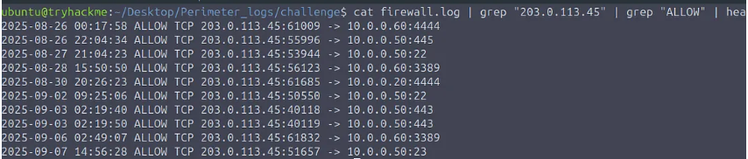

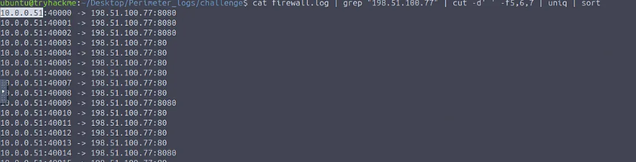
Result:
Thus, the Network Security Essentials room was completed successfully in TryHackMe. Knowledge about network threats, security devices, secure communication methods, and network protection techniques was gained successfully.

ANALYZE THE MALICIOUS NETWORK TRAFFIC USING TRYHACKME
Expt:4
Aim:
To investigate and analyze a compromised Windows system using digital forensics techniques, identify malicious activities, and understand how attackers operate through the TryHackMe Carnage room.

Procedure:
- Logged in to the TryHackMe platform using registered credentials and navigated to the Carnage room to begin the structured learning exercise.
- Carefully reviewed the incident scenario provided in the room, identifying the scope of the compromise and the available forensic evidence. Collected and catalogued all provided evidence files including memory dumps, disk images, log files, and network captures for systematic analysis.
- Systematically analyzed Windows Event Logs, application logs, and prefetch files to reconstruct user and system activity. Examined suspicious files using hashing and file metadata analysis, and reviewed artifacts such as browser history, recently opened files, and temporary directories for indicators of compromise.
- Used forensic tools to examine running and historical process lists, reviewed Windows Registry hives (HKLM\SOFTWARE\Microsoft\Windows\CurrentVersion\Run) for persistence entries, analyzed startup folder contents, and examined scheduled task configurations (schtasks) to identify attacker-installed persistence mechanisms.
- Compiled a comprehensive list of Indicators of Compromise (IOCs) including malicious file hashes, suspicious domain names and IP addresses contacted by the malware, unauthorized user accounts, and registry keys modified for persistence. Mapped identified attacker actions to the MITRE ATT&CK framework for structured threat characterization.
- Applied digital forensic tools including Autopsy, FTK Imager, and Volatility to inspect collected evidence. Recovered deleted files, extracted artifacts from memory dumps, and analyzed network packet captures to reconstruct the attacker's actions and uncover previously hidden evidence.
- Reconstructed the complete attack timeline from initial infection vector through to post-compromise activities by correlating timestamps across multiple evidence sources. Determined the root cause of the compromise, documenting the sequence of attacker actions to support incident reporting and future prevention measures.
- Answered all questions and completed the room successfully.

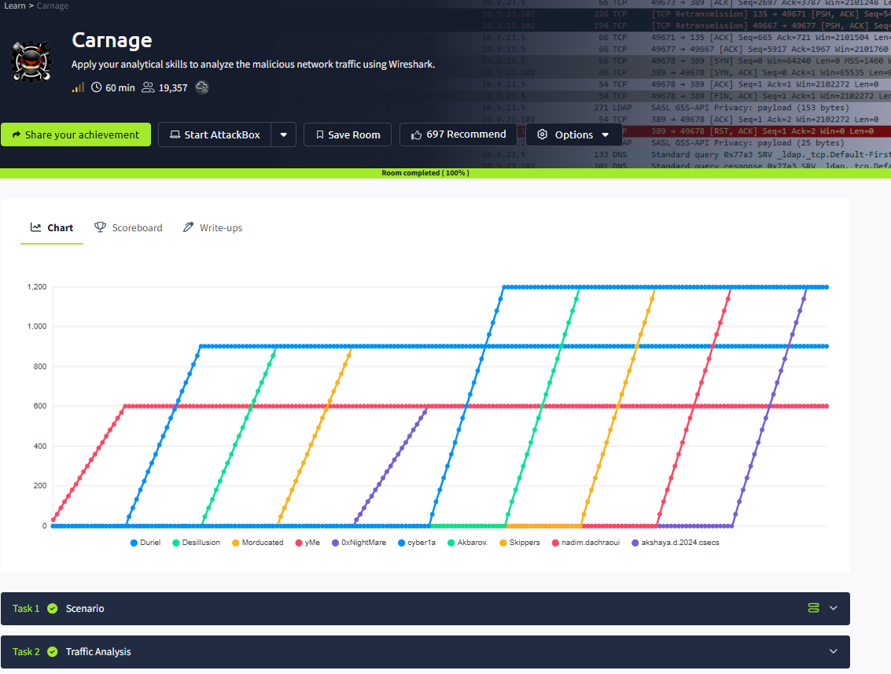
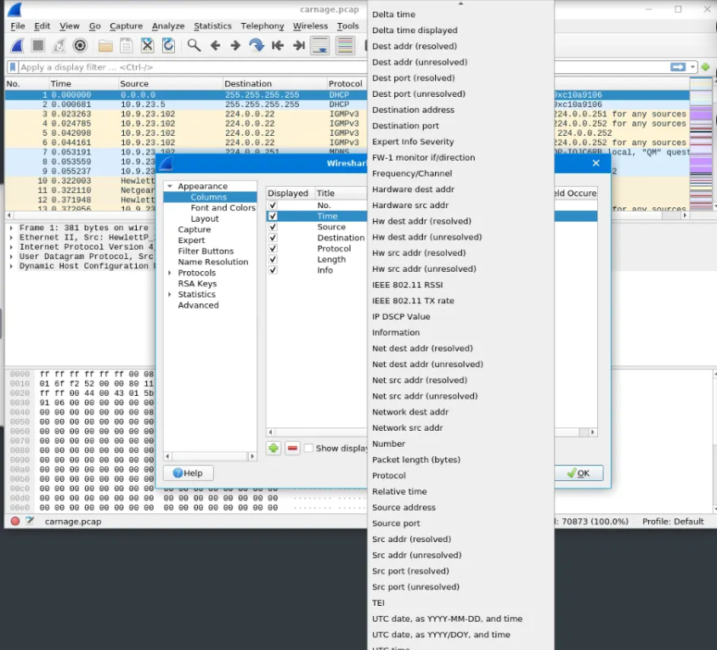

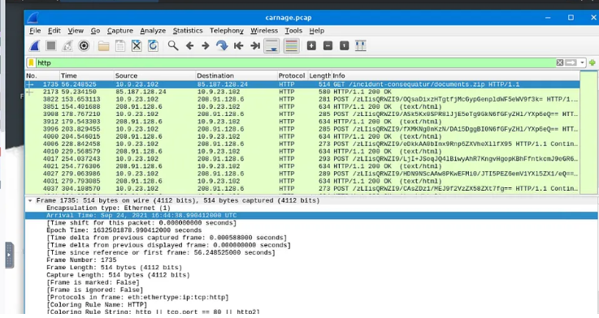
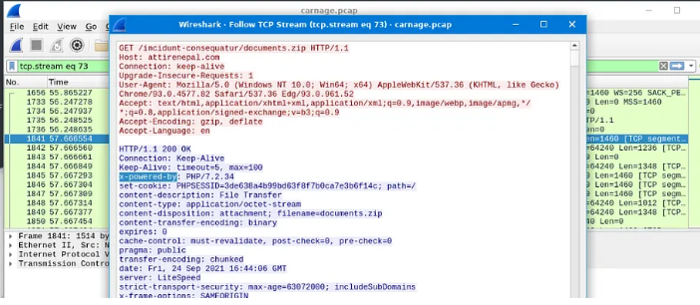

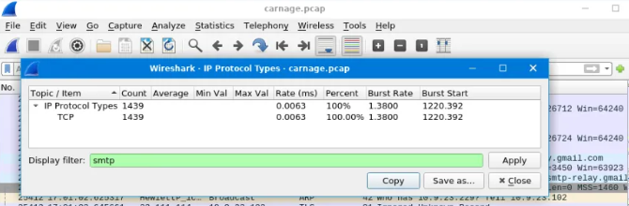

Result:
Thus, the Carnage room was completed successfully in TryHackMe. Knowledge about Windows forensics, malware investigation, persistence mechanisms, and incident analysis was gained successfully.

STACK BASED BUFFER OVERFLOW ATTACK
Expt:5
Aim:
To understand the concept of buffer overflow vulnerabilities in the sudo program, analyze privilege escalation techniques, and learn methods to identify and exploit such security weaknesses through the TryHackMe platform.
Procedure:
- Logged in to the TryHackMe platform using registered credentials and navigated to the Sudo Buffer Overflow room to begin the structured learning exercise.
- Carefully reviewed the room scenario and background materials describing the sudo utility's role in Unix/Linux privilege management. Studied how sudo allows standard users to execute commands with elevated (root) privileges and why vulnerabilities in such a critical utility can have severe security implications.
- Studied the concept of buffer overflow, where excess input overwrites memory.
- Used the lab environment to analyze the specific vulnerable version of the sudo binary, examining its memory layout, input handling routines, and the absence of adequate bounds checking. Studied the CVE associated with the vulnerability and reviewed how it was publicly disclosed and patched.
- Traced the code path through which malformed user input reaches an unchecked buffer copy operation, leading to memory corruption. Examined how the overwritten data can be crafted to redirect execution flow to attacker-controlled shellcode or to trigger the execution of existing code (ret2libc attacks).
- In the controlled TryHackMe lab environment, crafted a proof-of-concept exploit payload that successfully triggered the buffer overflow vulnerability, overwriting the return address to gain elevated (root) privileges. Observed the behavior of the exploited process and confirmed privilege escalation success.
- Studied comprehensive mitigation strategies including applying vendor-supplied security patches promptly, enforcing memory safety through compiler protections such as ASLR (Address Space Layout Randomization), stack canaries, and NX (No-Execute) bits, and adopting secure coding practices including mandatory input length validation and boundary checks.
- Successfully completed all interactive tasks, practical exercises, and comprehension questions within the room. Demonstrated a consolidated understanding of Windows security tools, update mechanisms, networking utilities, and PowerShell fundamentals required for real-world Windows administration.

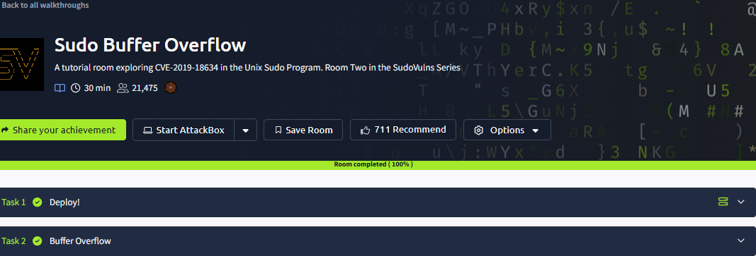
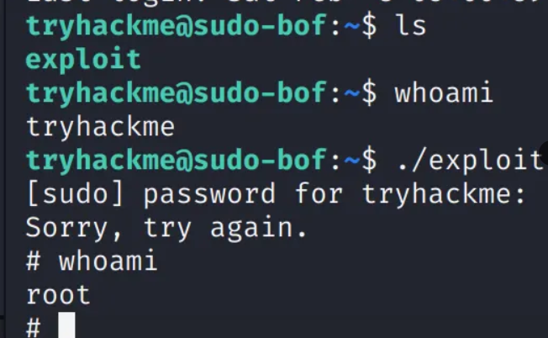

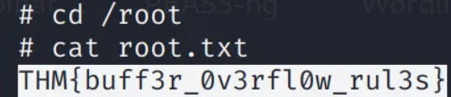

Result:
Thus, the Sudo Buffer Overflow room was completed successfully in TryHackMe. Knowledge about buffer overflow attacks, privilege escalation, sudo vulnerabilities, and security mitigation techniques was gained successfully.

DEMONSTRATE LINUX PRIVILEGE ESCALATION
Expt:6
Aim:
To thoroughly understand the techniques and methodologies attackers use to escalate privileges on Linux systems by exploiting misconfigurations, weak permissions, and insecure service setups. This experiment covers system enumeration, SUID/SGID exploitation, cron job abuse, sudo privilege misuse, PATH hijacking, and environment variable manipulation through the TryHackMe Linux Privilege Escalation room, developing skills critical for penetration testing and system hardening.
Procedure:
- Logged in to the TryHackMe platform using registered credentials and navigated to the Linux Privilege Escalation room to begin the structured learning exercise.
- Examined the Linux system environment including the operating system version, kernel version, installed packages, and configured user accounts. Reviewed the Unix permission model including read/write/execute bits for owner, group, and others, and the role of sudo in delegating elevated privileges.
- Performed systematic system enumeration using commands such as uname -a for kernel version, ps aux for running processes, id and whoami for current user context, cat /etc/passwd and cat /etc/group for user and group listings, and netstat -tulnp for active network listeners. This information gathering phase is critical for identifying exploitation opportunities.
- Checked for misconfigured SUID/SGID files, writable files, and insecure permissions.
- Reviewed system and user cron jobs in /etc/cron* directories and the crontab of various users for tasks running as root that involve writable scripts or commands. Demonstrated how an attacker could modify such scripts to execute arbitrary commands with elevated privileges when the scheduled task next runs.
- Executed sudo -l to enumerate which commands the current user is permitted to execute with elevated privileges. Cross-referenced identified allowed commands against GTFOBins to identify known privilege escalation techniques applicable to specific binaries, such as using sudo vi or sudo less to spawn a privileged shell.
- Examined environment variables including PATH, LD_PRELOAD, and LD_LIBRARY_PATH for exploitation opportunities. Demonstrated PATH hijacking by placing a malicious executable in a directory earlier in the PATH than the intended binary. Analyzed weak service configurations including insecurely configured systemd unit files and services running with unnecessary privileges.
- Applied the discovered privilege escalation vectors in the controlled TryHackMe lab environment, successfully gaining root access through multiple techniques. Documented each escalation path, the conditions that made it possible, and the corresponding remediation steps to prevent such vulnerabilities in production Linux systems.
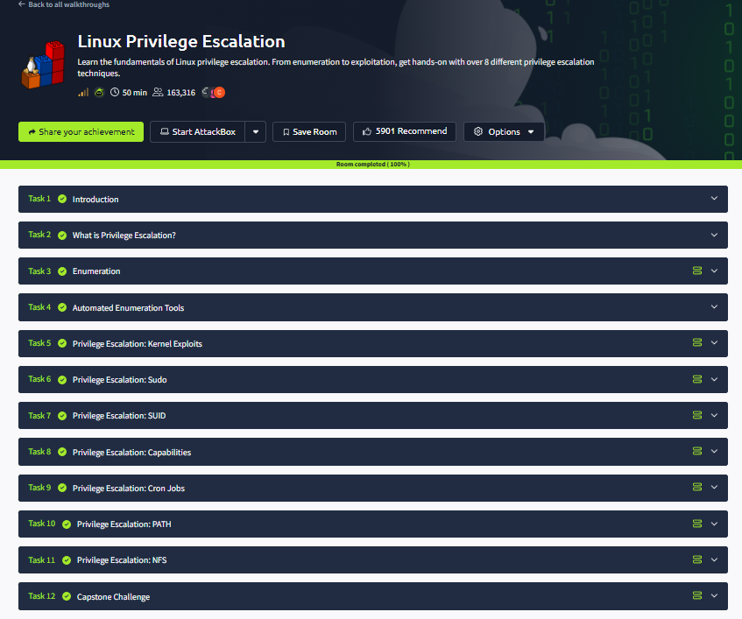

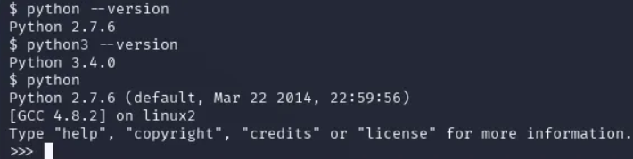

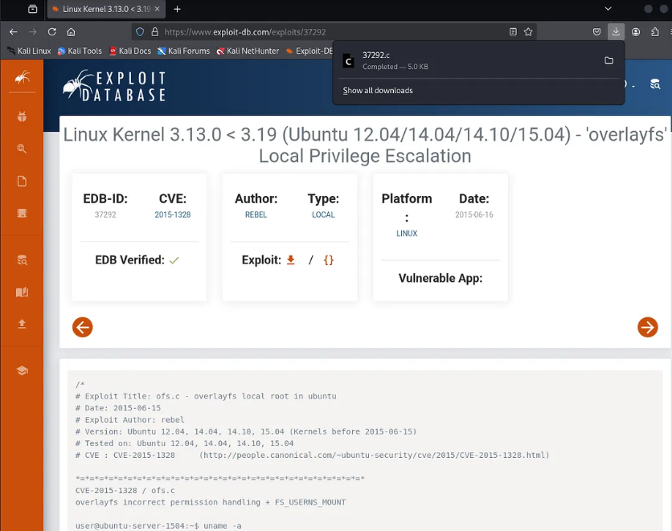
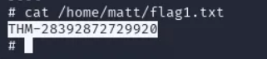

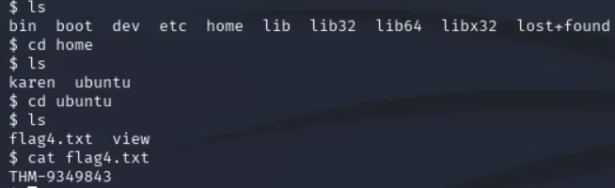

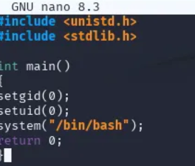
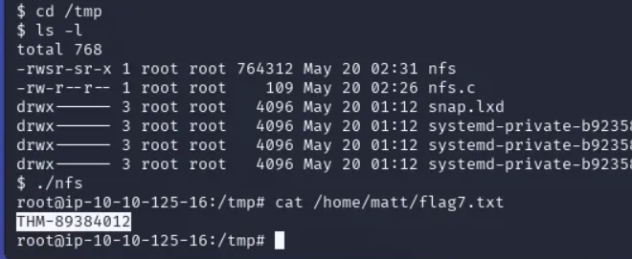
Result:
Thus, the Linux Privilege Escalation room was completed successfully in TryHackMe. Knowledge about Linux permissions, system enumeration, common vulnerabilities, and privilege escalation techniques was gained successfully.

SECURE NETWORK ARCHITECTURE
Expt:7
Aim:
To develop a comprehensive understanding of how secure network architectures are designed and implemented in enterprise environments, including the use of network zones, segmentation strategies, and layered defense mechanisms. This experiment covers DMZ design, VLAN configuration, firewall rule management, VPN deployment, and IDS/IPS integration through the TryHackMe Secure Network Architecture room, providing students with practical knowledge for designing resilient and secure organizational networks.
Procedure:
- Logged in to the TryHackMe platform using registered credentials and navigated to the Secure Network Architecture room to begin the structured learning exercise.
- Studied the defense-in-depth principle as the foundation of secure network architecture, understanding that multiple overlapping security controls create a layered defense that remains effective even if individual layers are breached. Explored how combining physical, technical, and administrative controls provides comprehensive protection.
- Examined the concept of network segmentation through security zones: the internal trusted network for corporate resources, the DMZ (Demilitarized Zone) for publicly accessible servers such as web and email servers, the external untrusted network (internet), and isolated guest networks. Understood how zone-based firewalling controls inter-zone traffic flows.
- Analyzed how perimeter firewalls, internal firewalls, and Next-Generation Firewalls (NGFWs) work together to enforce security policies at network boundaries. Studied how routers implement access control lists (ACLs) for packet filtering and how managed switches enforce port security, VLANs, and spanning tree configurations.
- Studied Virtual LAN (VLAN) technology for logically separating network traffic at the data link layer without requiring physical separation. Examined how subnetting divides IP address space into network segments, and how the combination of VLANs and subnetting enables granular traffic isolation and access control between different organizational units.
- Examined Virtual Private Network (VPN) technologies including IPSec VPN, SSL/TLS VPN, and WireGuard for establishing encrypted tunnels over untrusted networks. Studied site-to-site VPN configurations for branch office connectivity and remote access VPN for secure employee connections, including split tunneling considerations.
- Analyzed the deployment of Network-Based IDS/IPS (NIDS/NIPS) at strategic network choke points to monitor traffic for attack signatures and behavioral anomalies. Compared inline IPS deployment (which can actively block threats) with out-of-band IDS (which monitors passively and generates alerts). Studied Snort and Suricata as open-source examples.
- Studied the operational security practices essential for maintaining a secure network architecture over time: enforcing strict access control policies using role-based access control (RBAC) and the principle of least privilege, implementing continuous network monitoring through SIEM systems and traffic analysis, and maintaining a rigorous patch management program for all network devices and systems.
- Completed all tasks and answered the room questions successfully.
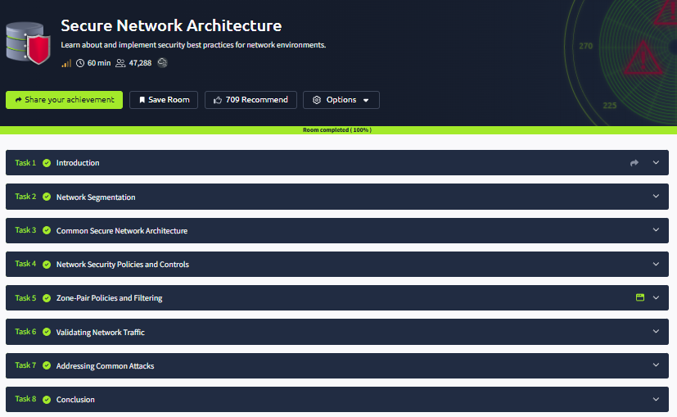

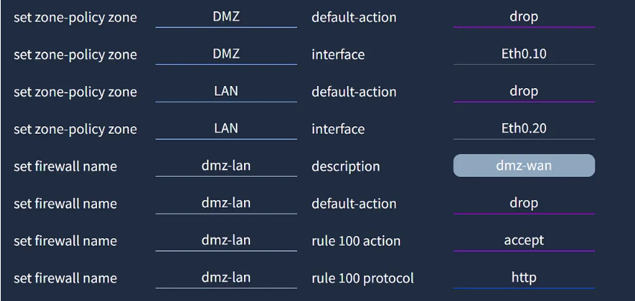

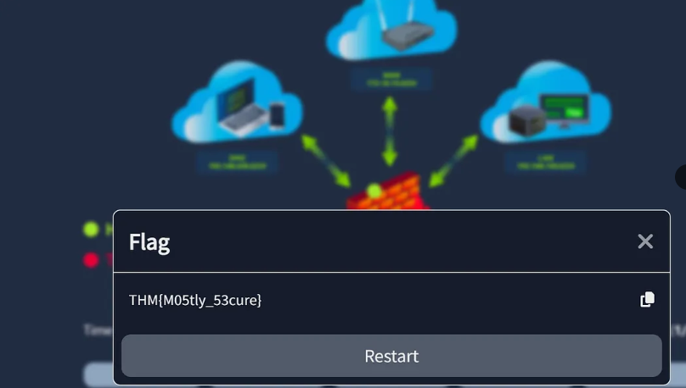

Result:
Thus, the Secure Network Architecture room was completed successfully in TryHackMe. Knowledge about secure network design, segmentation, firewalls, VPNs, and network protection techniques was gained successfully.

PERFORM ROOTKIT DETECTION AND REMOVAL USING RKHUNTER TOOL
Expt:8
Aim:
To gain practical expertise in Linux file system forensics by examining the hierarchical directory structure, analyzing critical system files and configuration directories, and applying forensic techniques to identify suspicious or unauthorized file system changes. This experiment uses the TryHackMe Linux File System Analysis room to develop investigative skills including file permission analysis, ownership examination, and artifact discovery essential for incident response and digital forensics.
Procedure:
- Logged in to the TryHackMe platform using registered credentials and navigated to the Linux File System Analysis room to begin the structured learning exercise.
- Studied the Filesystem Hierarchy Standard (FHS) governing the organization of the Linux directory tree, beginning with the root directory (/). Understood how all file system components, including physical devices, virtual file systems, and remote mounts, are integrated into a single hierarchical tree structure in Linux.
- Examined the purpose and contents of critical Linux directories: /bin and /sbin for essential system binaries, /etc for system-wide configuration files, /home for user profile directories, /var for variable data including logs and spool files, /tmp for temporary files, /usr for user-space programs and libraries, and /proc and /sys as virtual file systems exposing kernel data.
- Reviewed critical configuration files including /etc/passwd and /etc/shadow for user account information, /etc/group for group memberships, /etc/hosts and /etc/resolv.conf for network configuration, and /etc/sudoers for privilege delegation. Examined system log files in /var/log including auth.log, syslog, and kern.log for system events and anomalies.
- Applied essential Linux command-line tools for file system investigation: ls -la for detailed file listings including hidden files and permissions, find with various predicates for locating specific files, cat and less for file content examination, grep for pattern-based content searching, stat for detailed file metadata, and file for determining file types based on magic bytes.
- Analyzed file permission bits (read/write/execute for owner, group, and others), special permission bits (SUID, SGID, sticky bit), and file ownership (user and group). Examined hidden files and directories (those beginning with a dot) which are commonly used by both legitimate applications and attackers to conceal configuration files or malicious tools.
- Applied forensic analysis techniques to identify anomalous files: files with world-writable permissions in system directories, binaries with unexpected SUID bits, recently modified system files, files with unusual names or extensions, and hidden files in unexpected locations such as /tmp or user home directories. Correlated findings to assess potential indicators of compromise.
- Successfully completed all interactive tasks, practical exercises, and comprehension questions within the room. Demonstrated a consolidated understanding of Windows security tools, update mechanisms, networking utilities, and PowerShell fundamentals required for real-world Windows administration.
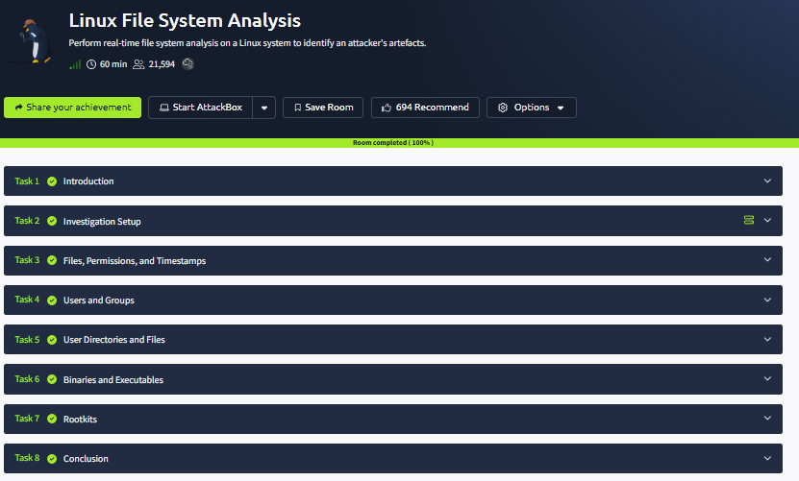
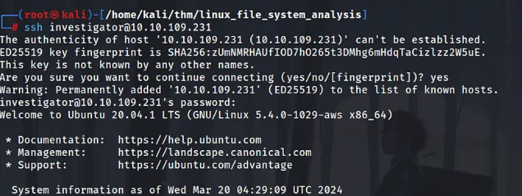

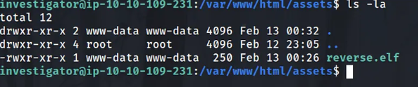
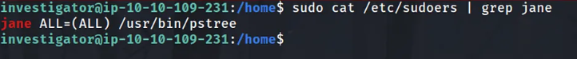
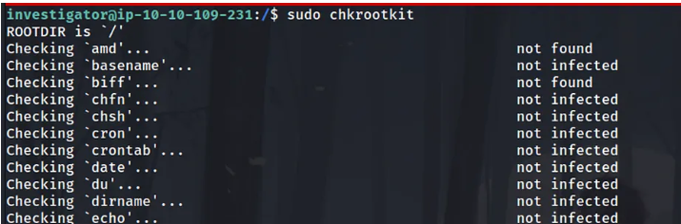

Result:
Thus, the Linux File System Analysis room was completed successfully in TryHackMe. Knowledge about Linux directory structure, file permissions, system files, and basic forensic analysis was gained successfully.

DEPLOYMENT OF HONEYPOTS AND ANALYSIS OF BOTNET ACTIVITIES
Expt:9
Aim:
To develop a thorough understanding of honeypot technology as a proactive cybersecurity deception mechanism, including the architectural differences between low-interaction and high-interaction honeypots, their deployment strategies, and their role in capturing attacker behavior and collecting threat intelligence. This experiment uses the TryHackMe Introduction to Honeypots room to understand how honeypots contribute to improved incident response, threat detection, and security posture enhancement.
Procedure:
- Logged in to the TryHackMe platform using registered credentials and navigated to the Introduction to Honeypots room to begin the structured learning exercise.
- Studied the conceptual definition and strategic purpose of honeypots as deliberately deployed decoy systems, services, or data designed to attract and deceive attackers. Understood how honeypots mimic legitimate targets to lure malicious actors away from real assets while enabling security teams to observe, record, and analyze attacker behavior in a controlled environment.
- Examined how honeypots serve dual functions: as early warning systems that generate high-fidelity alerts when attackers interact with them (since no legitimate traffic is expected), and as threat intelligence collection platforms that capture attacker tools, techniques, and procedures (TTPs) for security research and defensive improvement.
- Compared low-interaction honeypots, which simulate limited services and are easier to deploy and maintain with lower risk, to high-interaction honeypots that provide full system access, generating richer intelligence but requiring more resources and careful containment to prevent attackers from pivoting through them to real systems. Also studied honeynets as networks of interconnected honeypots.
- Studied the data capture mechanisms used by honeypots including network traffic logging, keystroke recording, file system change monitoring, and process execution tracking. Analyzed how captured attacker sessions can be replayed and studied to understand attack methodologies, identify threat actors, and improve defensive controls.
- Evaluated the strategic advantages of honeypots including generating high-confidence alerts, providing attacker intelligence, and diverting resources away from real targets. Also examined limitations such as the risk of honeypots being identified and avoided by sophisticated attackers, legal considerations around entrapment, and the need for careful network isolation to prevent honeypot compromise from spreading.
- Studied how threat intelligence gathered from honeypot deployments is operationalized to improve security defenses: updating firewall rules and IDS signatures based on observed attack techniques, training incident response teams using real captured attack scenarios, and informing threat hunting activities by identifying active threat actor infrastructure and TTPs.
- Successfully completed all interactive tasks, practical exercises, and comprehension questions within the room. Demonstrated a consolidated understanding of Windows security tools, update mechanisms, networking utilities, and PowerShell fundamentals required for real-world Windows administration.
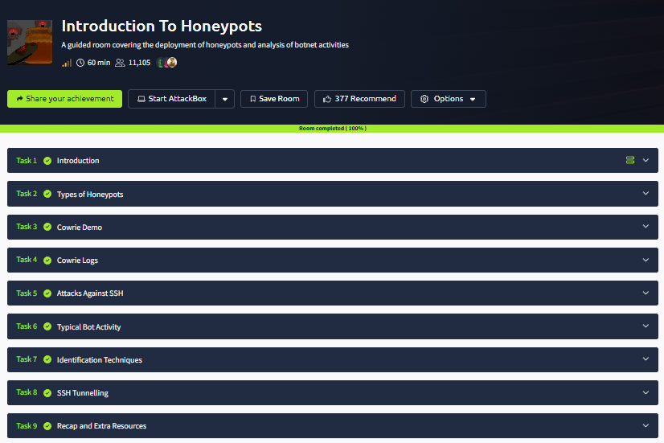

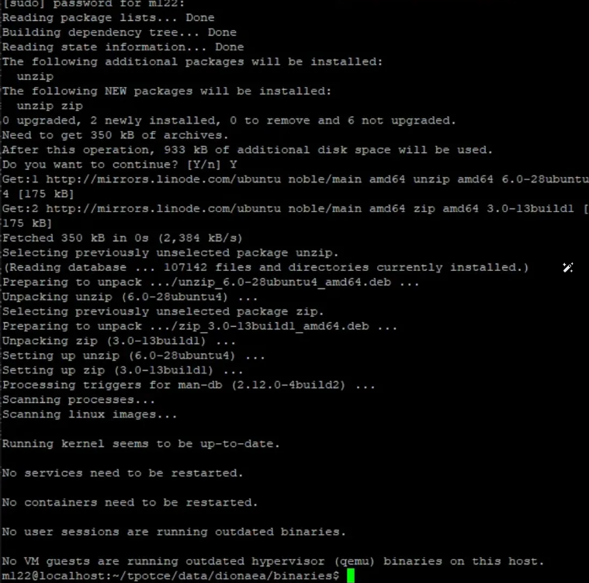
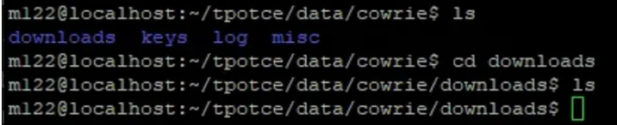

Result:
Thus, the Introduction to Honeypots room was completed successfully in TryHackMe. Knowledge about honeypot concepts, types, uses, and their role in detecting cyber threats was gained successfully.

EXPLORE ANTIVIRUS DETECTION TECHNIQUES
Expt:10
Aim:
To build a comprehensive understanding of antivirus software architecture, malware detection methodologies, and the critical role endpoint protection plays in modern cybersecurity defense. This experiment covers signature-based detection, heuristic analysis, behavior-based detection, real-time protection features, and virus definition management through the TryHackMe Introduction to Antivirus room, equipping students with practical knowledge to evaluate and deploy effective antivirus solutions.
Procedure:
- Logged in to the TryHackMe platform using registered credentials and navigated to the Introduction to Antivirus room to begin the structured learning exercise.
- Studied the core mission of antivirus software as a critical endpoint security control designed to detect malicious code before it executes, prevent malware installation and propagation, and remove identified threats from infected systems. Examined how modern antivirus solutions have evolved from simple virus scanners to comprehensive endpoint protection platforms (EPP).
- Analyzed the characteristics and behaviors of major malware categories: viruses that self-replicate by attaching to legitimate files, worms that propagate autonomously across networks, trojans that disguise malicious functionality as legitimate software, ransomware that encrypts victim data and demands payment, spyware that secretly exfiltrates sensitive information, adware, keyloggers, and rootkits that provide persistent attacker access.
- Examined the three primary antivirus detection paradigms: signature-based detection using hash databases and byte pattern matching for known malware, heuristic analysis that identifies suspicious code patterns and characteristics in potentially unknown samples, and behavior-based (dynamic) detection that monitors runtime program actions to identify malicious behavior regardless of file signature.
- Studied how real-time on-access scanning intercepts file operations to scan content before execution, how scheduled full-system scans provide periodic comprehensive checks, and how the quarantine system isolates suspected malware in a restricted container to prevent execution while allowing potential false positives to be reviewed and restored.
- Analyzed why continuous updates to virus definition databases are critical for maintaining detection effectiveness against new and evolving malware. Studied the update lifecycle from malware discovery by security researchers to signature generation, testing, and distribution. Understood how keeping antivirus software itself patched prevents exploitation of vulnerabilities in the security product.
- Examined security best practices that complement antivirus protection: keeping the operating system and applications fully patched, practicing safe browsing and email hygiene, using standard user accounts for daily tasks to limit malware impact, regularly backing up important data to offline or isolated storage, and combining antivirus with other security controls such as firewalls and application whitelisting.
- Successfully completed all interactive tasks, practical exercises, and comprehension questions within the room. Demonstrated a consolidated understanding of Windows security tools, update mechanisms, networking utilities, and PowerShell fundamentals required for real-world Windows administration.

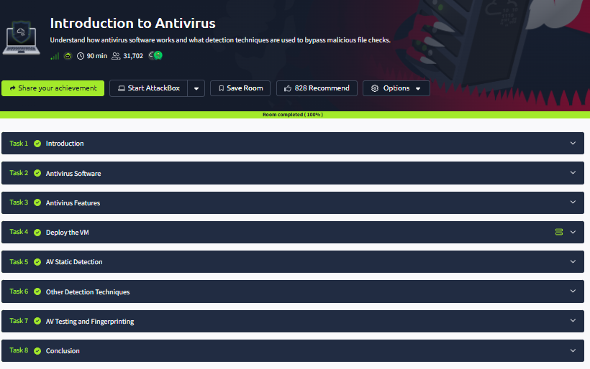

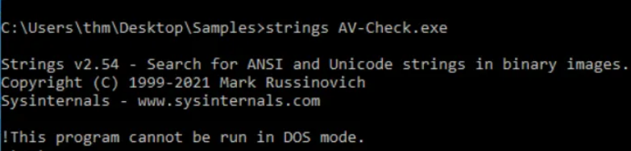

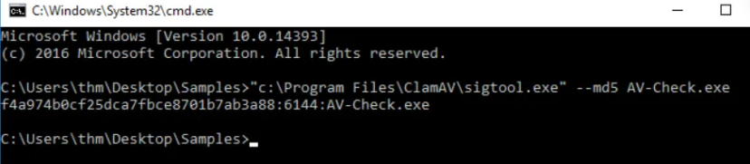

Result:
Thus, the Introduction to Antivirus room was completed successfully in TryHackMe. Knowledge about antivirus concepts, malware detection techniques, and system protection methods was gained successfully.

EXPLORE TOR NETWORK FOR ANONYMOUS COMMUNICATION
Expt:11
Aim:
To develop a detailed understanding of the Tor (The Onion Router) network's architecture, cryptographic mechanisms, and anonymization capabilities used for privacy-preserving communication on the internet. This experiment examines how Tor routes traffic through multiple relay nodes using layered encryption, the function of the Tor Browser, hidden services accessed via .onion domains, and the practical security considerations and limitations of using Tor for anonymous communication, using the TryHackMe Tor room.
Procedure:
- Logged in to the TryHackMe platform using registered credentials and navigated to the Tor room to begin the structured learning exercise.
- Learned the full form of Tor as The Onion Router.
- Examined the Tor circuit establishment process in which the Tor client selects a path of three relay nodes (Guard/Entry, Middle, and Exit relays) from the distributed Tor network. Understood how the client establishes encrypted channels with each relay so that no single node knows both the source and destination of the traffic, providing anonymity through separation of knowledge.
- Analyzed the onion encryption mechanism: the Tor client encrypts the data payload in multiple layers, one for each relay node. Each relay decrypts one layer (using its own private key) and forwards the remaining encrypted payload to the next relay, with the Exit node delivering the final plaintext to the destination, analogous to peeling layers of an onion.
- Examined the Tor Browser, a hardened version of Firefox configured to route all traffic through the Tor network. Studied its built-in privacy protections including disabled browser fingerprinting, blocked third-party cookies, HTTPS enforcement, and NoScript integration, and understood the tradeoffs between anonymity and browsing speed due to multi-hop routing latency.
- Studied Tor Hidden Services (now called Onion Services) which allow servers to be hosted anonymously within the Tor network, accessible only through .onion addresses. Examined the introduction point and rendezvous point mechanism that enables two-way anonymous communication, and discussed legitimate uses such as whistleblower platforms alongside criminal applications on the dark web.
- Evaluated Tor's anonymity guarantees and practical limitations: while Tor effectively hides user IP addresses from websites and ISPs, it does not protect against traffic correlation attacks by a global passive adversary, exit node eavesdropping on unencrypted traffic, browser fingerprinting, or user operational security mistakes that can de-anonymize Tor users.
- Successfully completed all interactive tasks, practical exercises, and comprehension questions within the room. Demonstrated a consolidated understanding of Windows security tools, update mechanisms, networking utilities, and PowerShell fundamentals required for real-world Windows administration.
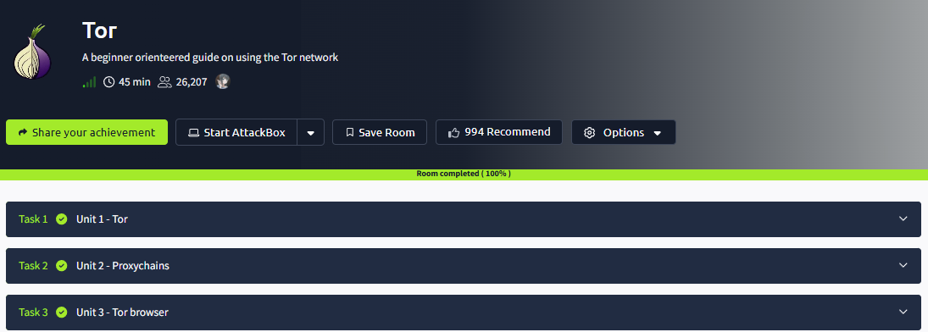

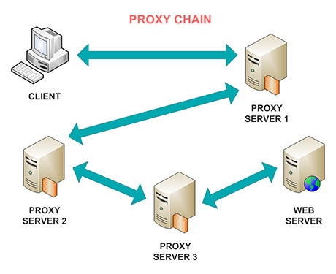

Result:
Thus, the Tor room was completed successfully in TryHackMe. Knowledge about onion routing, anonymous communication, relay nodes, and secure browsing using the Tor network was gained successfully.

DEMONSTRATE CYBER EVASION TECHNIQUES

Expt:12
Aim:
To develop a thorough understanding of Intrusion Detection Systems (IDS) and Intrusion Prevention Systems (IPS), their architectural types, detection methodologies, and their essential role in identifying and responding to malicious activities within computer networks. This experiment covers Network-Based IDS (NIDS), Host-Based IDS (HIDS), signature-based and anomaly-based detection methods, alert generation, event logging, and incident response workflows through the TryHackMe Intrusion Detection room.
Procedure:
- Logged in to the TryHackMe platform using registered credentials and navigated to the Intrusion Detection room to begin the structured learning exercise.
- Studied the definition and core function of an Intrusion Detection System (IDS) as a security monitoring tool designed to passively observe network traffic, system activities, and log data to identify patterns indicative of attacks, policy violations, or unauthorized access attempts. Understood the distinction between passive detection-only IDS and active response-capable IPS.
- Examined the two primary IDS deployment architectures and their respective use cases:
  - Network-Based IDS (NIDS)
  - Host-Based IDS (HIDS)
- Compared the two fundamental IDS detection methodologies: signature-based detection (also called misuse detection) that matches observed activity against a database of known attack patterns with high accuracy but inability to detect zero-day attacks, and anomaly-based detection that establishes behavioral baselines and flags statistical deviations, capable of detecting novel attacks but prone to higher false-positive rates.
- Studied the data sources and analysis techniques used by IDS: network traffic capture and protocol analysis using deep packet inspection (DPI), log aggregation and correlation from multiple sources, file integrity monitoring using cryptographic hashing, and behavioral analysis using machine learning models to identify patterns deviating from established baselines.
- Examined how IDS systems generate and manage alerts, including alert prioritization based on severity, the role of Security Information and Event Management (SIEM) platforms in aggregating and correlating IDS alerts with other security events, and the incident response workflow triggered by IDS detections including investigation, containment, and remediation steps.
- Analyzed the key architectural and functional differences between IDS (passive monitoring and alerting only) and IPS (active inline blocking and mitigation). Examined the tradeoffs of IPS deployment including the risk of false positives causing legitimate traffic disruption, the need for high availability configurations to prevent IPS from becoming a network bottleneck, and hybrid IDPS approaches.
- Successfully completed all interactive tasks, practical exercises, and comprehension questions within the room. Demonstrated a consolidated understanding of Windows security tools, update mechanisms, networking utilities, and PowerShell fundamentals required for real-world Windows administration.
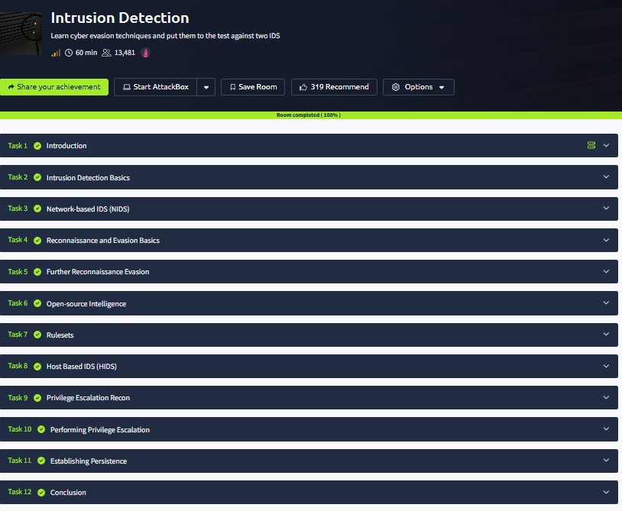
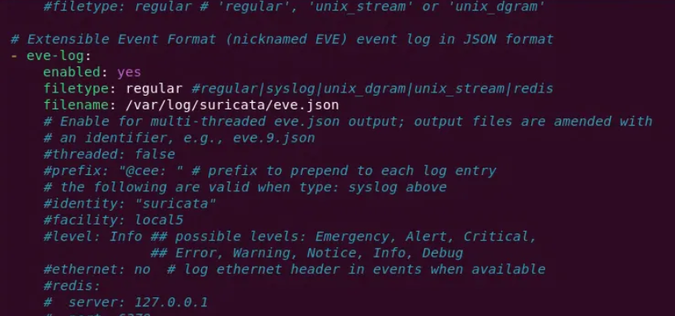
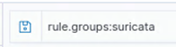

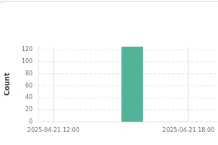

Result:
Thus, the Intrusion Detection room was completed successfully in TryHackMe. Knowledge about IDS types, detection techniques, alerts, and monitoring malicious activities was gained successfully.

THREAT INTELLIGENCE FOR SOC
Expt:13
Aim:
To develop a comprehensive understanding of threat intelligence and its strategic, tactical, operational, and technical dimensions within a Security Operations Center (SOC) environment. This experiment examines how SOC analysts collect, process, and apply threat intelligence data including Indicators of Compromise (IOCs), threat feeds, and intelligence platforms to enhance detection capabilities, accelerate incident response, and proactively defend against evolving cyber threats using the TryHackMe Threat Intelligence for SOC room.
Procedure:
- Logged in to the TryHackMe platform using registered credentials and navigated to the Threat Intelligence for SOC room to begin the structured learning exercise.
- Studied the definition of cyber threat intelligence (CTI) as the collection, processing, analysis, and dissemination of information about current and potential cyber threats that enables organizations to make informed security decisions. Examined the threat intelligence lifecycle from planning and collection through analysis, dissemination, and feedback.
- Examined the four threat intelligence categories: Strategic intelligence (high-level trends and threat actor motivations for executive decision-making), Tactical intelligence (TTPs and attack methodologies for security architecture decisions), Operational intelligence (specific planned attacks and threat actor campaigns), and Technical intelligence (IOCs, malware signatures, and technical artifacts for immediate defensive action).
- Studied the concept of Indicators of Compromise (IOCs) as forensic artifacts that indicate potential malicious activity. Examined common IOC types including malicious IP addresses and CIDR ranges, suspicious domain names and DNS patterns, file hashes (MD5, SHA-1, SHA-256) of known malware, malicious URLs and URI patterns, and registry keys or file paths associated with specific threat actors or malware families.
- Examined how SOC analysts consume threat intelligence through automated threat feeds (STIX/TAXII protocols), commercial threat intelligence platforms such as Recorded Future and CrowdStrike Falcon Intelligence, open-source platforms such as MISP (Malware Information Sharing Platform), and community-driven intelligence sharing via ISACs (Information Sharing and Analysis Centers).
- Analyzed how operationalized threat intelligence improves each phase of the security operations cycle: enriching SIEM alerts with contextual threat actor information, informing threat hunting hypotheses, accelerating triage by providing historical context for observed IOCs, enabling proactive blocking of known malicious infrastructure, and improving post-incident reporting with attribution context.
- Studied alert correlation techniques that combine real-time security events with current threat intelligence to reduce false positives, prioritize high-fidelity alerts, and provide analysts with the context needed to assess the true risk of observed activity. Examined how SIEM rules and SOAR playbooks integrate threat intelligence feeds to automate initial alert enrichment and triage.
- Completed all tasks and answered the room questions successfully.
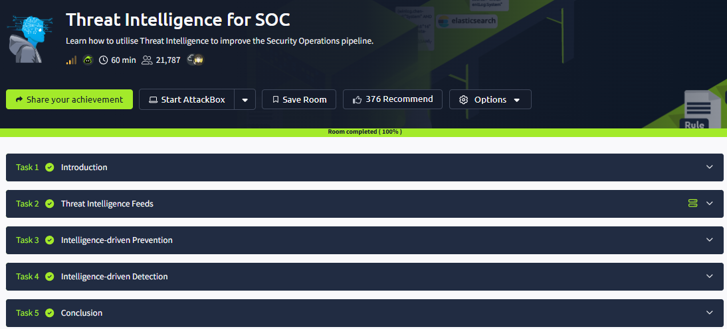

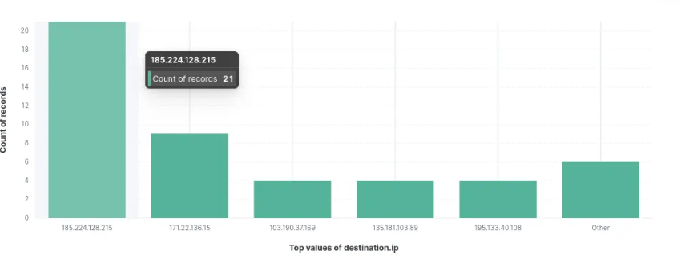
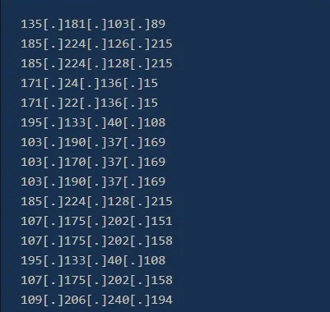
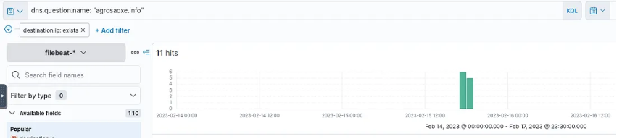
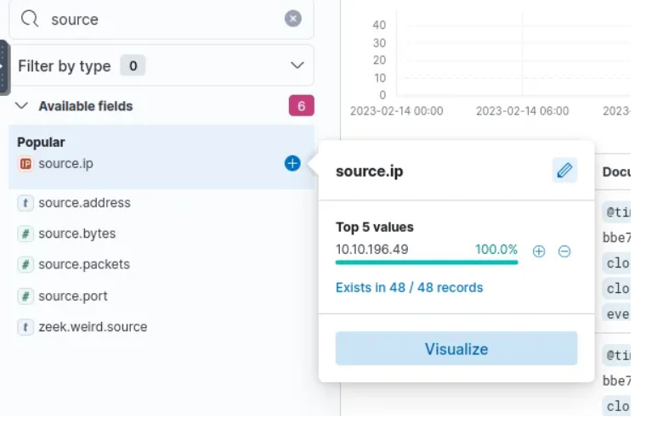

Result:
Thus, the Threat Intelligence for SOC room was completed successfully in TryHackMe. Knowledge about threat intelligence types, IOCs, SOC monitoring, and cyber threat response was gained successfully.

LOG ANALYSIS FOR DETECTION AND RESPONSE
Expt:14
Aim:
To develop practical log analysis skills essential for security monitoring, incident investigation, and threat detection by examining various log types generated by operating systems, applications, firewalls, and network devices. This experiment covers log collection methodologies, event correlation, filtering techniques, and identification of suspicious activities such as failed authentication attempts, unauthorized access, and anomalous network behavior using the TryHackMe Intro to Log Analysis room.
Procedure:
- Logged in to the TryHackMe platform using registered credentials and navigated to the Intro to Log Analysis room to begin the structured learning exercise.
- Studied the fundamental concept of security logs as chronological records of events occurring within operating systems, applications, network devices, and security controls. Understood how logs serve as the primary data source for security monitoring, incident investigation, compliance auditing, and forensic analysis, and why log integrity and completeness are critical security requirements.
- Examined the major log categories and their information value: System logs recording OS-level events including startup/shutdown and hardware errors, Security/Authentication logs capturing login attempts, privilege use, and policy changes, Application logs from web servers, databases, and custom applications, Firewall and network device logs recording allowed and denied traffic, and Endpoint Detection and Response (EDR) logs providing detailed endpoint activity telemetry.
- Analyzed the three primary use cases for security logs: continuous monitoring to detect anomalies and security events in real-time through SIEM correlation rules, troubleshooting to diagnose system failures and performance issues, and incident investigation to reconstruct the timeline of a security breach, identify the initial compromise vector, trace attacker lateral movement, and determine the scope of data access.
- Practiced log analysis using Linux command-line tools (grep, awk, sed, sort, uniq) for searching and filtering log files. Applied structured query tools for parsing log formats such as Apache access logs, Windows Event Logs, and JSON-structured application logs. Used log aggregation and search platforms to correlate events across multiple log sources and identify patterns.
- Applied analytical techniques to identify security-relevant events in logs: multiple failed authentication attempts from the same source indicating brute-force attacks, successful logins at unusual hours or from unexpected geographies, privilege escalation events, access to sensitive files by unauthorized users, unusual outbound connections to known malicious IPs or high-entropy domain names, and anomalous data transfer volumes indicating potential exfiltration.
- Studied the critical role of log metadata in forensic investigations: timestamps with timezone information for accurate timeline construction and correlation across systems, source and destination IP addresses for identifying actors and communication paths, Windows Event IDs as standardized identifiers for specific security events (e.g., Event ID 4625 for failed logon, 4688 for process creation), and process/user identifiers for establishing audit trails.
- Successfully completed all interactive tasks, practical exercises, and comprehension questions within the room. Demonstrated a consolidated understanding of Windows security tools, update mechanisms, networking utilities, and PowerShell fundamentals required for real-world Windows administration.
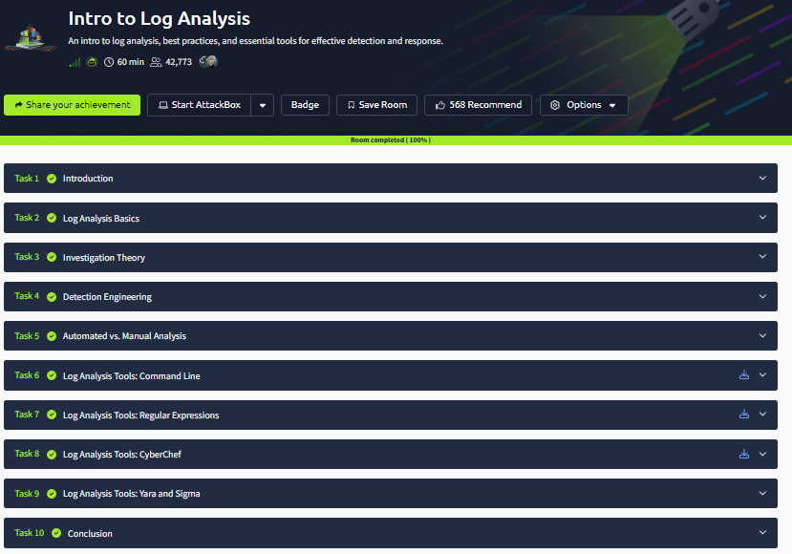
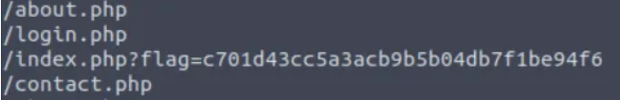
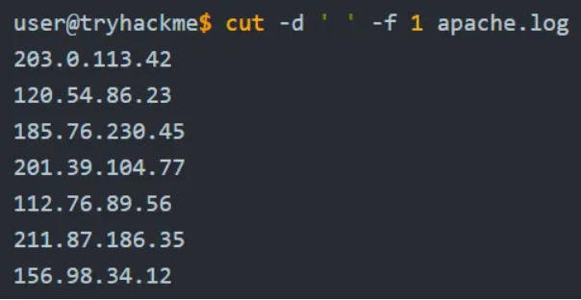
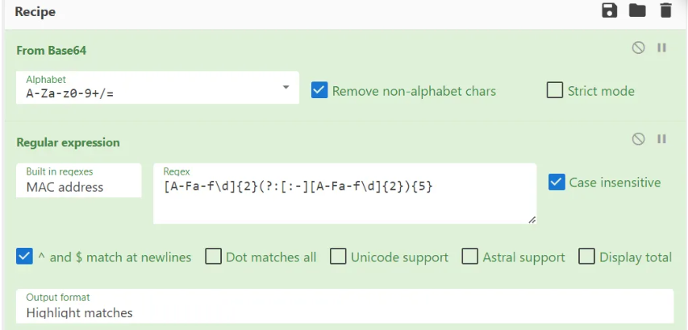

Result:
Thus, the Intro to Log Analysis room was completed successfully in TryHackMe. Knowledge about log sources, event monitoring, suspicious activity detection, and security investigation was gained successfully.

ENDPOINT SECURITY MONITORING
Expt:15
Aim:
To build a comprehensive understanding of endpoint security monitoring principles, tools, and methodologies used to detect, investigate, and respond to threats targeting endpoint devices such as desktops, laptops, servers, and mobile devices. This experiment covers Endpoint Detection and Response (EDR) solutions, process monitoring, file integrity analysis, user activity tracking, and alert-driven incident response using the TryHackMe Endpoint Security Monitoring room.
Procedure:
- Logged in to the TryHackMe platform using registered credentials and navigated to the Endpoint Security Monitoring room to begin the structured learning exercise.
- Studied the definition of endpoints as any device that connects to an organizational network, including desktops, laptops, servers, mobile phones, tablets, IoT devices, and virtual machines. Understood why endpoints represent a primary attack surface since they interact directly with users and external data sources, making them frequent targets for initial compromise.
- Examined the strategic importance of endpoint security monitoring as a critical component of defense-in-depth security architecture. Studied how continuous monitoring of endpoint activities enables security teams to detect threats that bypass perimeter controls, identify unauthorized activities and policy violations, investigate security incidents with detailed endpoint telemetry, and contain threats before they spread laterally.
- Analyzed the endpoint security tool ecosystem including traditional antivirus for known malware detection, Endpoint Detection and Response (EDR) platforms (such as CrowdStrike Falcon, Carbon Black, and Microsoft Defender for Endpoint) for advanced threat detection and forensic investigation, Data Loss Prevention (DLP) for sensitive data protection, application control and whitelisting for restricting unauthorized software execution, and host-based firewalls for network traffic control at the endpoint level.
- Studied the data sources available for endpoint security monitoring: process execution logs with parent-child relationships and command-line arguments, file system change events including creation, modification, and deletion of files in sensitive directories, user login and authentication events, registry modification logs on Windows, and network connection events showing which processes are communicating with which remote endpoints.
- Applied behavioral analysis techniques to identify endpoint-level indicators of compromise: processes executing from unusual paths (e.g., malware masquerading as system processes in temp directories), unexpected parent-child process relationships (e.g., a word processor spawning a command shell), processes attempting to modify system files or registry keys associated with persistence, unusual outbound connections to high-entropy domain names or Tor exit nodes, and lateral movement indicators such as remote process execution via PsExec or WMI.
- Examined the end-to-end incident response workflow triggered by endpoint security monitoring alerts: initial alert triage and severity assessment, endpoint isolation to prevent further compromise spread, forensic data collection using EDR platform capabilities, root cause analysis to determine the initial infection vector, threat eradication and system remediation, and post-incident lessons learned review. Studied how SOAR (Security Orchestration, Automation, and Response) platforms can automate initial response actions to accelerate containment.
- Successfully completed all interactive tasks, practical exercises, and comprehension questions within the room. Demonstrated a consolidated understanding of Windows security tools, update mechanisms, networking utilities, and PowerShell fundamentals required for real-world Windows administration.
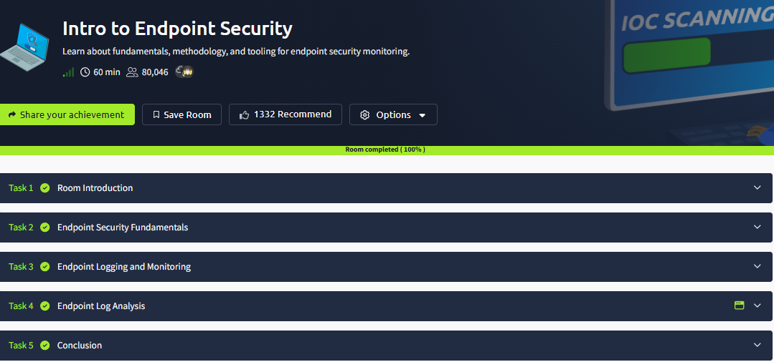

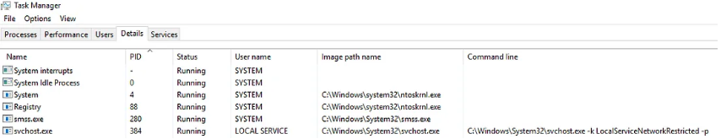
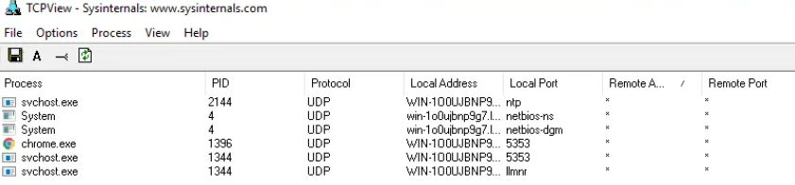
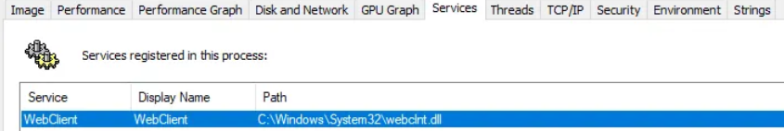
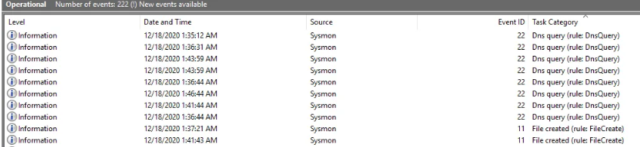
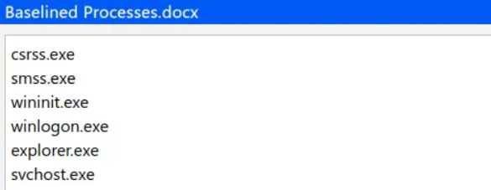
Result:
Thus, the Endpoint Security Monitoring room was completed successfully in TryHackMe. Knowledge about endpoint protection, threat detection, monitoring tools, and incident response was gained successfully.

